Aim: - Configuration of three routers using Cisco Packet Tracer.

Software Required: -

Cisco Packet Tracer 8.2.0

Procedure and Outputs: -

Step 1: - Select three routers and three switches from the bottom menu and put each switch below each router. Then put 3 PC each under each switch and connect them using wires.  
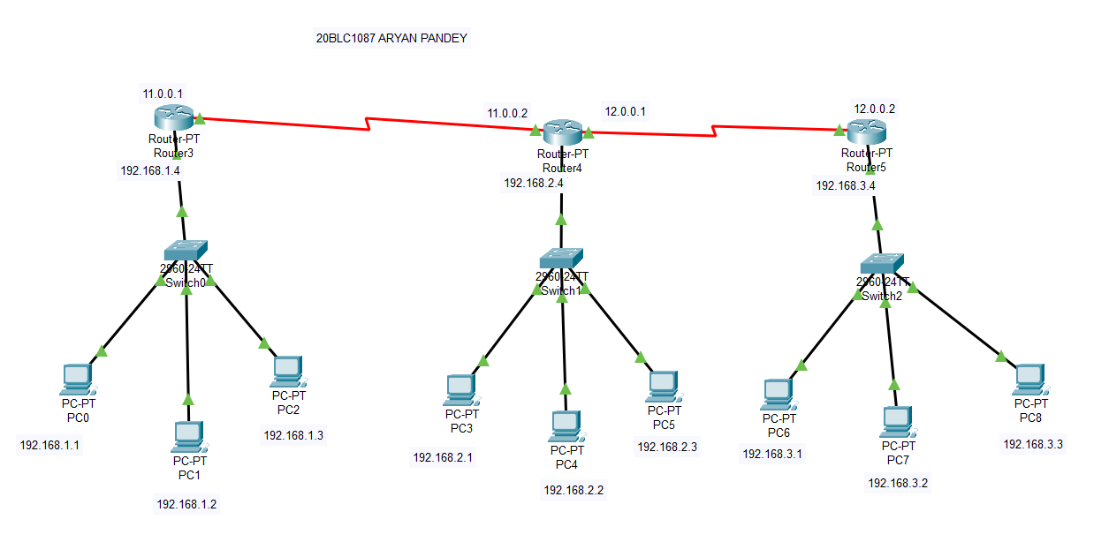

Step 2: - As shown above provide the IP address to the assigned PCs and switches and routers IP needs to be specially assigned. One for there connection with switches and one for there router to router connection.

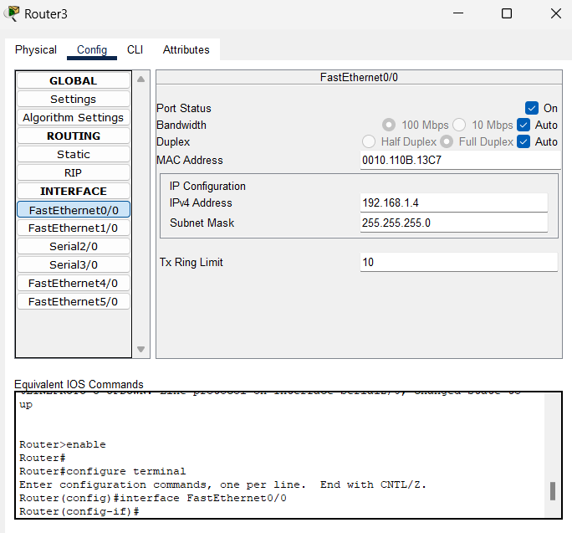

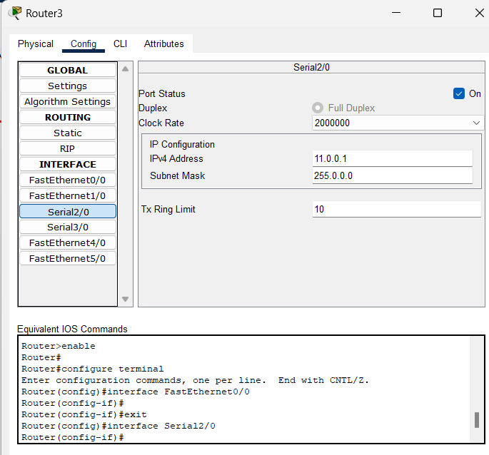

Step 3: - When doing the simulation select the packet from the upper tool box and then click on the sender PC and then to the receiver PC. Then click on the simulation button and click on run. Then we can see the packet flow through the one end to the receiver PC.

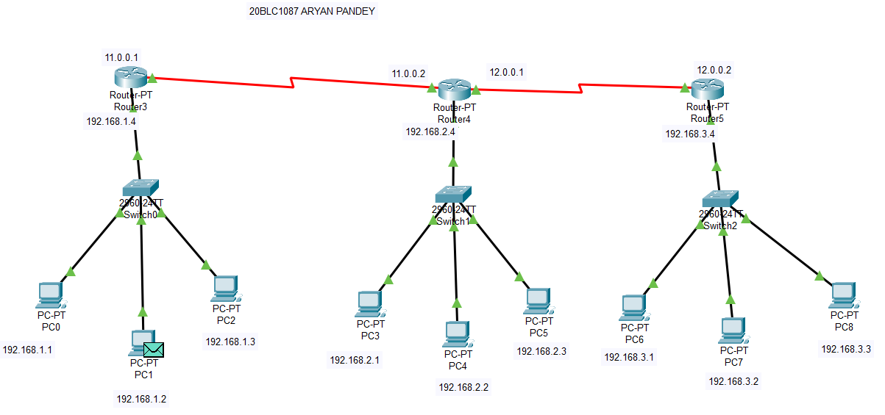

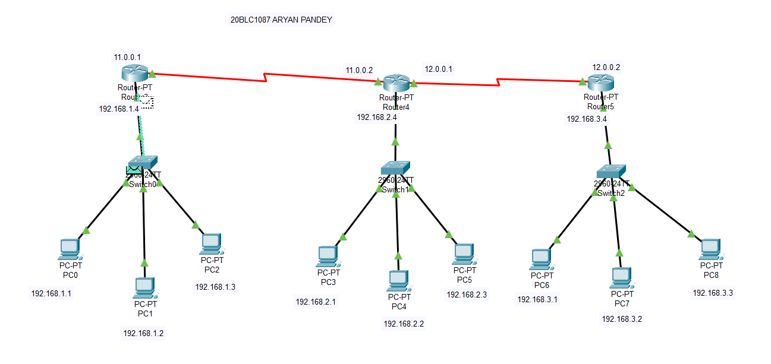

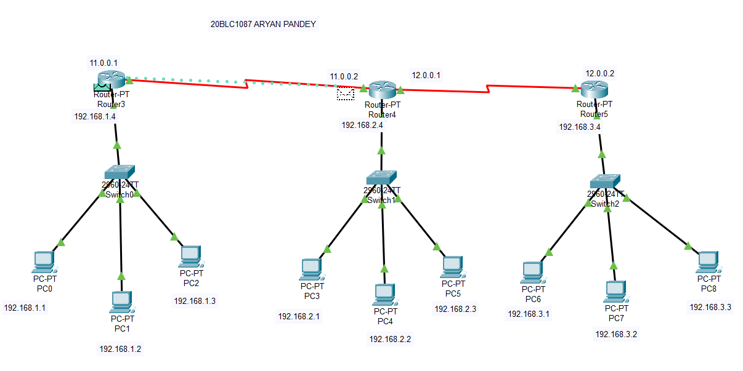

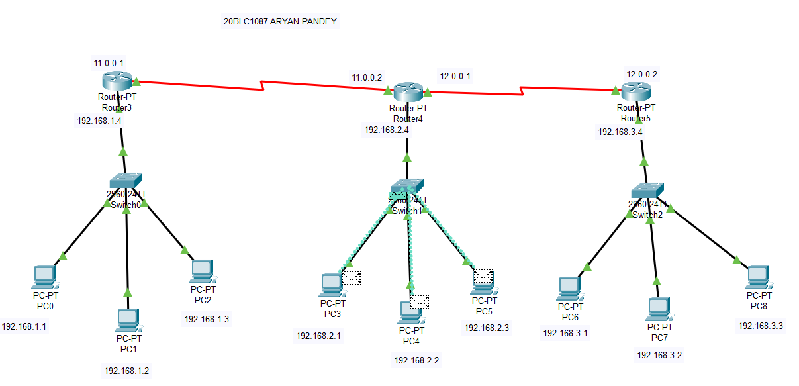

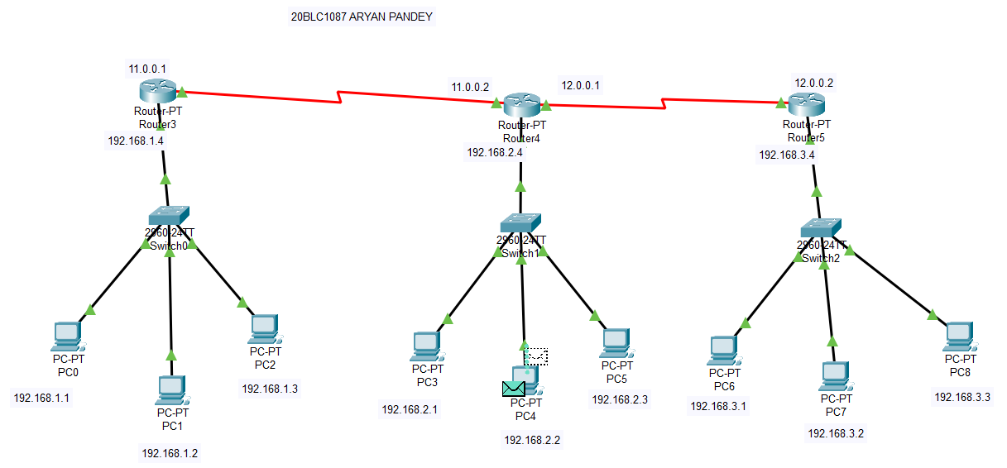

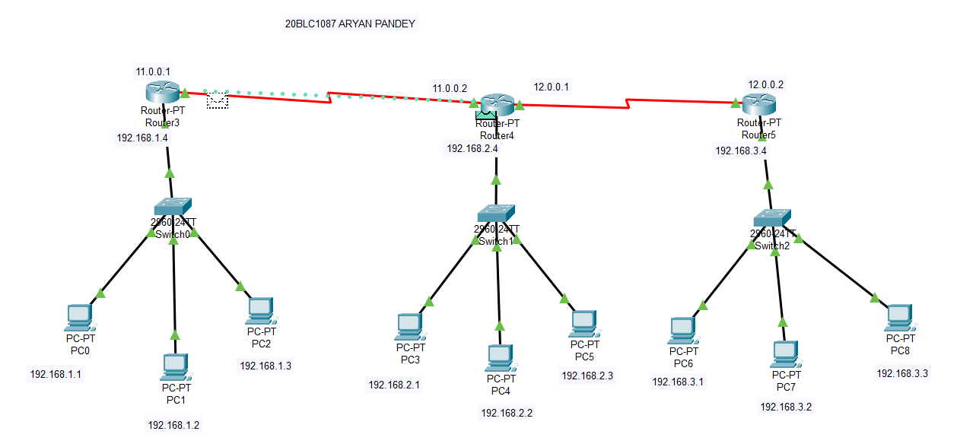

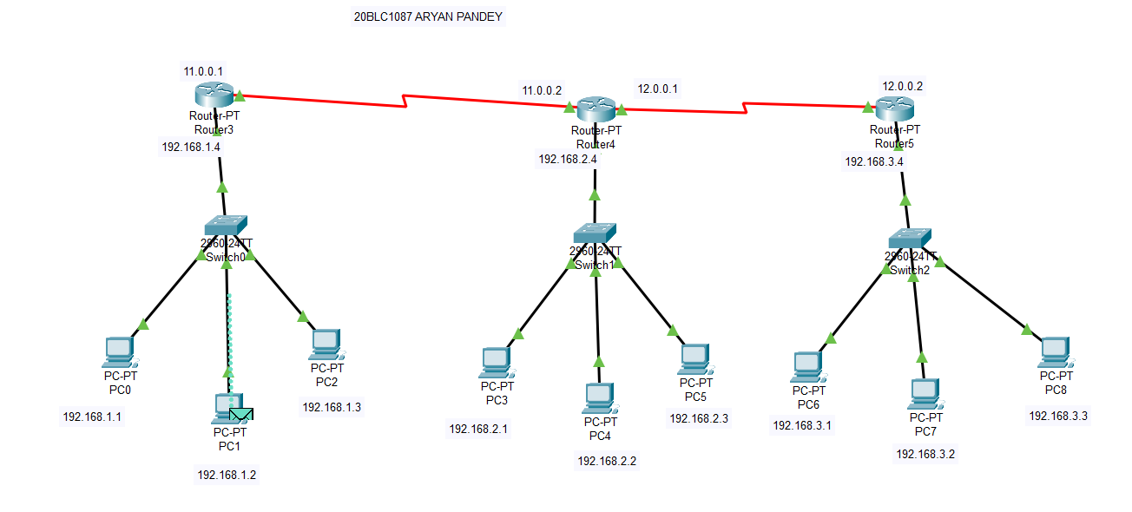

Result: -

Configuration of three routers using Cisco Packet Tracer.